**Humidity and temperature series**

This line of product are widely used in electronic devices, electronic products, material energy, pharmaceutical, chemical, automotive and aerospace industries.It can be used in constant alternating hot and humid and high temperature (hot and humid) and other tests for a variety of industrial products in the development, production, testing and other production procedures.Based on Zhuo Xi's patented Balanced Thermostat Humidity Control system (BTHC), dynamic PID and water vapor partial pressure control, the technology used is mature, has a extremely high precision, network control and data acquisition can be carried out via the relevant interfaces.These are all energy saving green products.

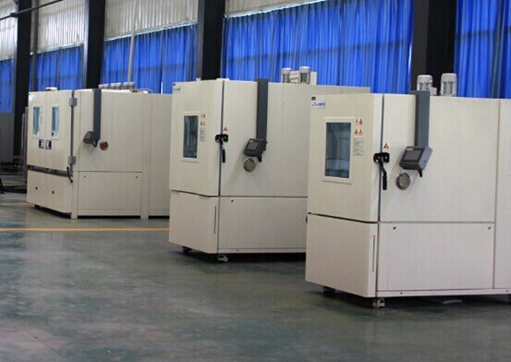

**High and low temperature (hot and humid) test chamber (SDJ Series)**

**SDJ series Temperature humidity chamber**

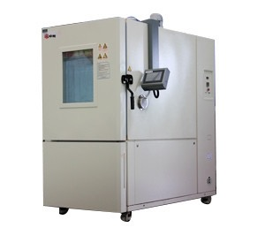

**Execution and meet the standards:** GB / T2423.1 / IEC60068-2-1, GB / T2423.3 / IEC60068-2-78, GB / T2423.4 / IEC60068-2-30, GB / T2423.34 / IEC60068-2 -38, JESD22-A100-C, JESD22-A101- C

**Uses:** Widely used in accelerated damp heat tests and alternating temperature tests for materials, equipment and other parts in electrical, electronic, aerospace, aviation, instrumentation and other industries in order to evaluate the performance of the trial target under given environmental conditions.

**Features:**

· 32-digit Intelligent Programmable Controller

High processing speed, clear interface display.Multiple language options, experimental data U-disk storage, LAN ports, and other functions.

· Standard test conditions program download

· Malfunction traceability and automatic detection

Running condition of the test chamber before the malfunction will be automatically recorded and saved, and then forwarded to the nearest service window to implement remote malfunction diagnosis and integrated inspection and repair.

· Remote monitoring communications and SMS alarm

Without using any driver program, simple remote monitoring the equipment by LAN.Real-time equipment malfunction alarms will be received on the preset phone number.

**Technical parameters:**

Model:

SDJ

201

202

205

210

401

402

405

410

701

702

705

710

**Temperature range:**

-20 ℃ ~ 100 ℃ (150 ℃)

-40 ℃ ~ 100 ℃ (150 ℃)

-70 ℃ ~ 100 ℃ (150 ℃)

Temperature fluctuation

± 0.5 ℃

Temperature deviation

± 2 ℃

Humidity range

30% -98% RH

Humidity uniformity

± 2 / -3% RH (when humidity> 75% RH)

Temperature Rising Time

-20 ℃ ~ + 100 ℃ about 80 min.

-40 ℃ ~ + 100 ℃ about 90 min.

-40 ℃ ~ + 100 ℃ about 90 min.

Temperature Falling Time

+20 ℃ ~ -20 ℃ about 50 min.

+20 ℃ ~ -40 ℃ about 80 min.

+20 ℃ ~ -70 ℃ about 90 min.

Internal space dimension (мм)

Type 01: 400 × 500 × 650, Тype 02: 500 × 600 × 700

Тype 05: 700 × 800 × 900, Тype 10: 1000 × 1000 × 1000

External dimension (мм)

Type 01: 1110 × 980 × 1510, Тype 02: 1140 × 1080 × 1560

Тype 05: 1340 × 1280 × 1760, Тype 10: 1640 × 1480 × 1860

Internal volume

100 L

200 L

500 L

1000 L

100 L

200 L

500 L

1000 L

100 L

200 L

500 L

1000 L

Optional accessory

[Communication](http://dict.youdao.com/w/communication/) [interface](http://dict.youdao.com/w/interface/) (RS485), printer, [recording](http://dict.youdao.com/w/recording/) [instrument](http://dict.youdao.com/w/instrument/) , computer and software for remote monitoring, division plate, platinum resistor PT100 etc.,

Remarks:

Inside and outside dimensions labeled: Depth D × Width w × Height H

The above data measured at temperature 20 ℃ under the condition of no-load.

**[Middle-sized](http://dict.youdao.com/w/middle-sized/) high and low temperature (hot and humid) test chamber**

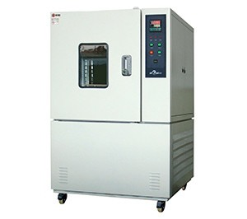

**Execution and meet the standard:**

Use: To meet a variety of needs of communications, automobile, new energy, industrial control other testing needs of large components.

**Features:**

• Internal volume:1,800 L, temperature change rate: 5℃ / min

• Left and right sides power detection ·

**Technical parameters:**

Temperature range: -70 ~ + 180 ℃;

Temperature change rate: 5 ℃ / min;

Humidity range: 20 to 98%;

Internal dimension: 1,800L