**Industrial Production Series - Laboratory equipment**

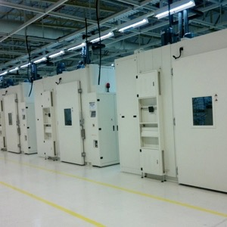

Applies to the need for in-power temperature testing and aging inspection of semiconductor, LCD, electronic products, precision instruments,etc.

**The following are subdirectories for this series of products:**

-----------------------------------------------

**Set temperature aging (assembly lines)**

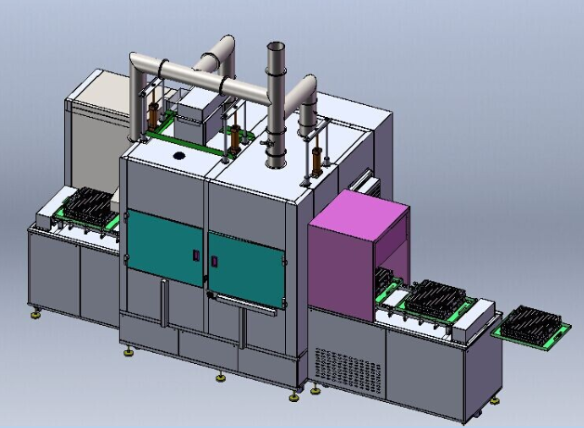

Execution and meet the standard:

Uses: Electronic products pipeline aging process

Features:

· Belt feed, improve production efficiency.

· All operating status displayed in front and back sides simultaneously.

· Automatic stop function to prevent wrong operation.

· In terms of security, equipped with automatic overheat prevention, over-preventive device, over current electric leakage protection, and other security measures.