**Walk-in series**

**-------------------------------------------------- ------------------**

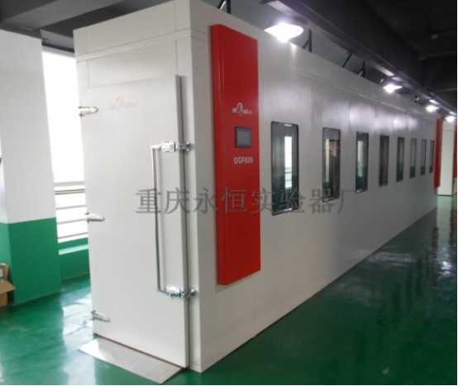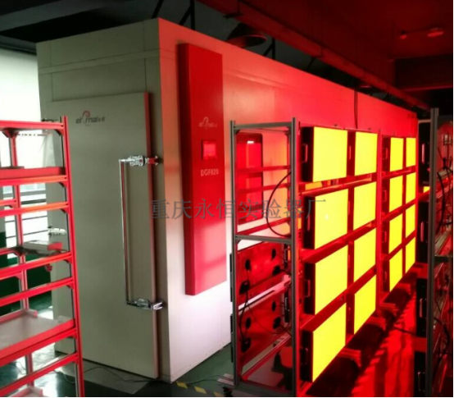

Walk-in temperature and humidity test chambers are widely used to detect electronic equipment, IT communications, motor transport, industrial electrical, instrumentation, materials, energy, chemical and construction products for environmental adaptability, including heat, cold, resistance to dry and moisture.It can add artificial combined stress like light, rain, stream, snow, vibration, etc. for the imitation of the all-weather operating conditions of the finished product, for product development assessment and final design evaluation.Group products include assembled one piece housing plate and standard series, can meet the needs from a simple aging room to a sophisticated multi-purpose laboratory.

-------------------------------------------------- -------------

# **Walk-In High and low temperature (hot and humid) Test Room**

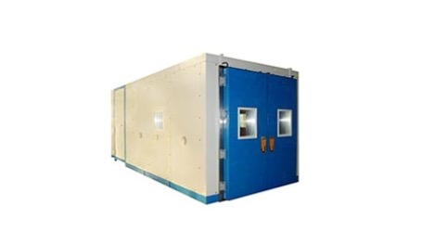

Execution and meet the standards: GB / T2423.3 (IEC60068-2-78), GB / T2423.4 (IEC60068-2-30), GB / T2423.34 (IEC60068-2-38), GB / T2423.40 ( IEC60068-2-66) / ISO16750, JESD22, GB / T 14710: 2009, GB / T 13543.

Uses: Suitable for the test of large components.

Features:

· Self made frame type treasury storehouse board, high strength, good thermal insulation effect

· Use of electronic expansion valve control technology, energy-saving, quick control

· Capacitance humidity sensor control, easy maintenance, high reliability

· Independent patented intelligent control system

Simply set the temperature and humidity conditions, the automatic control system will run at maximum power before reaching the set value, and at minimum power after reaching the set value.And it can respond quickly to the door switch and changes in heat load during the testing process in order to maintain a stable test environment.

· Energy saving mode

There are 2 modes, the standard mode and energy-saving mode to control of the consumption of electricity.You can switch between modes in accordance with the test conditions.The patent-pending new refrigeration system can accurately control output · freezing capacity, so as to achieve a significant energy saving effect.

· Automatic backup and continue to run function

In case a part of the test chamber fails, the remaining machines will continue to run without stopping the test.If the humidifier fails, the system will be switched to temperature control operation mode.

 Technical parameters:

Model

Temperature Range

Humidity range

Internal volume

 Type

Internal dimension

(W × H × Dmm)

ZXBR

-40 ~ + 80 ℃

20 ~ 98% RH

4,220L

Type 1

1,020 × 2,100 × 1,980

ZXBR

-40 ~ + 80 ℃

20 ~ 98% RH

8,150L

Type 2

1,960 × 2,100 × 1,980

ZXBR

-40 ~ + 80 ℃

20 ~ 95% RH

12,490L

Type 3

3,020 × 2,100 × 1,980

ZXBR

-70 ~ + 80 ℃

16,840L

Type 4

4,070 × 2,100 × 1,980

**HIDDEN TEXT**

This section contains tooltips, titles and other text that are usually hidden in the body of the HTML page. This text should be translated to bring the entire page into your language.

**HTML ELEMENTS**

Walk-in series